BARYS

Non-contact bore inspection for gun barrels – Qualification Questionnaire

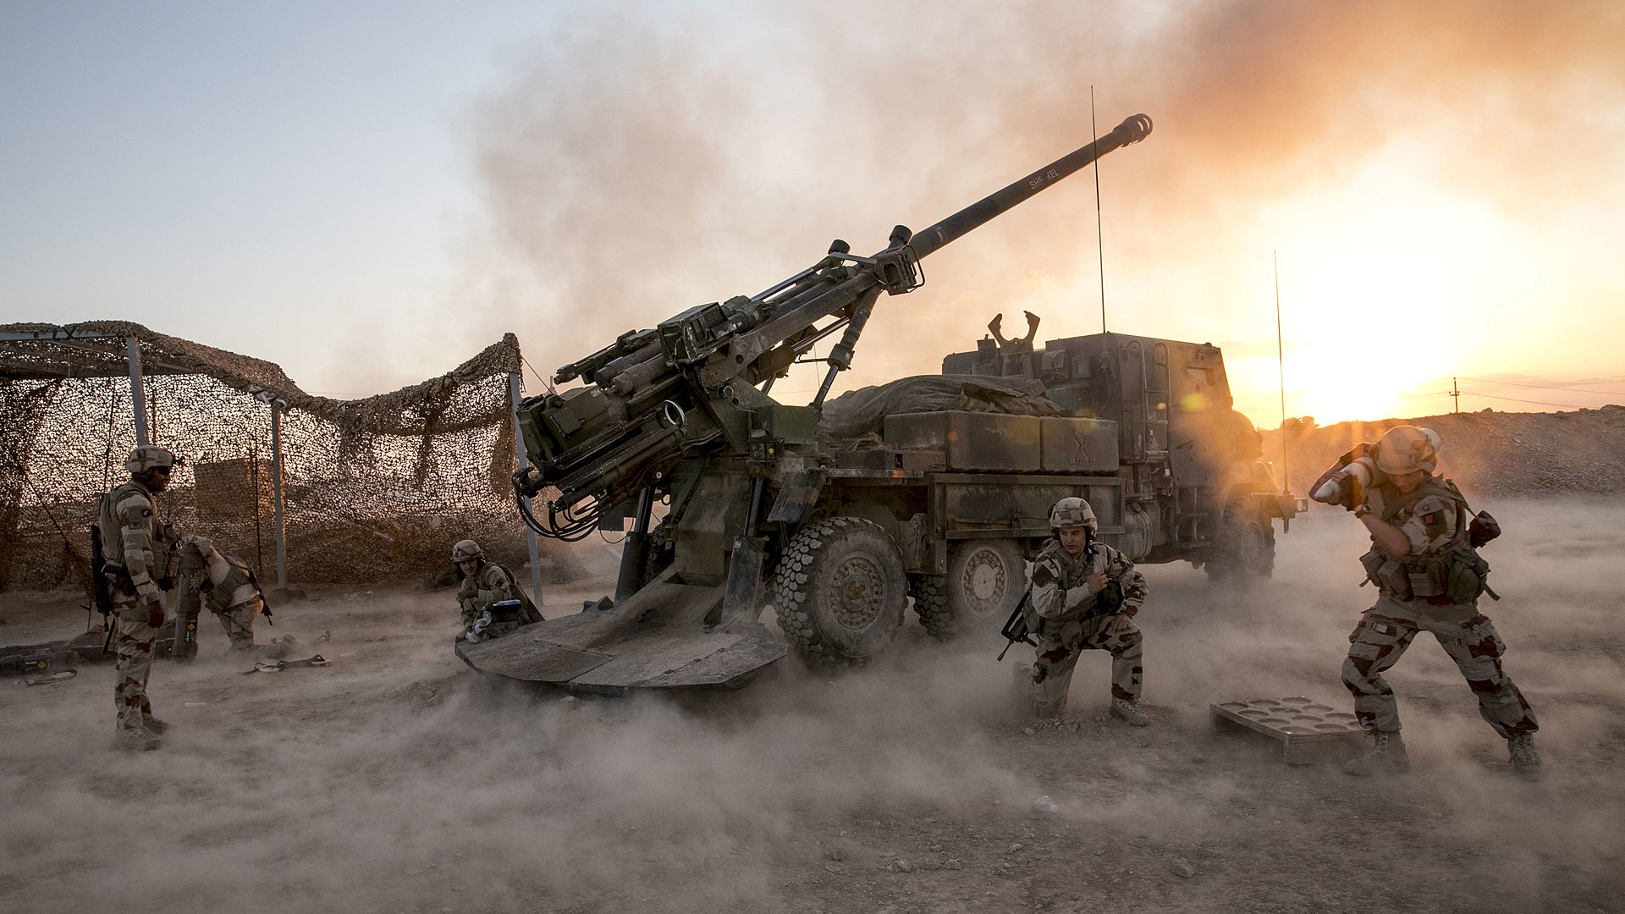

Your contact and project details:
Name :
Company Name :
GSM :
E-mail :
Address:

Technical details: (any drawings would help) to define measurement probe type and dimensions
In case of smooth bore
Tube origin (NATO or other) :
Tube length (mm) :
Length to be measured outside the chamber (mm) :
New tube diameter tolerance:
Tolerance on worn tube:
Chrome plating defect measurement : (yes/no)
Number of sections to be measured :
Needed length between tube and control unit ? (meter)
Any other specific requirement/measurement/report types:

In case of grooved bore
Tube origin (NATO or other) :
Tube length (mm) :
Length to be measured outside the chamber (mm) :
New tube caliber tolerance :
Tolerance on the groove bootom line of the new tube :
Wear tolerance of caliber :
Wear tolerance of the bottom of the groove :
Number of grooves :
Width and depth of grooves :
Twist angle and direction :
Number of sections to be measured :
Needed length between tube and control unit ? (meter)
Any other specific requirement/measurement/report types:

System and usage
Type of use (field, workshop, laboratory, other...) :
Need for visual inspection: (yes/no)
Automatic/manual system:
How many systems required:
Rate of use:
Are you currently using a system ? (yes/no)
If yes : Which system :
Characteristics of the product used :
What information is required? (Example: vehicle number, number of shots, etc.)
Need for maintenance contract/training ? (yes/no)
Country of use:
Allocated budget (EUR):

